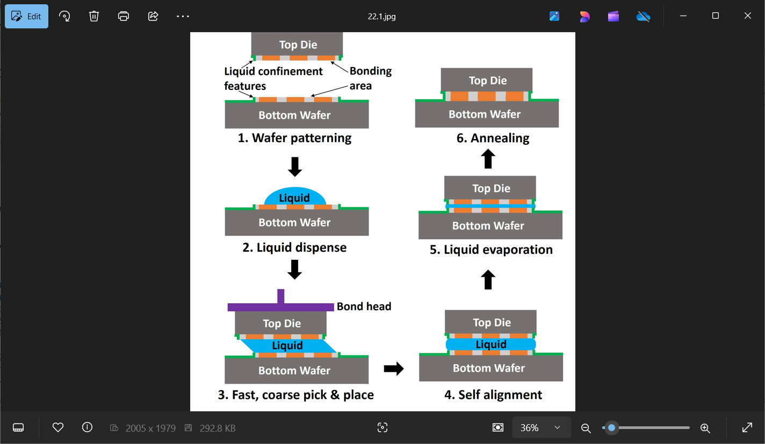

**Fluidic Self-Alignment for Hybrid Bonding:** Die-to-wafer hybrid bonding (D2W HB) has many advantages over traditional solder bonding, but it is costly because attaching chiplets to a wafer at extremely tight tolerances is slow and complicated. That will only get worse at smaller HB pitches and/or as the number of chiplets per stack increases. Intel researchers will describe the latest developments in the use of fluidic self-alignment to increase die-to-wafer hybrid bonding throughput. It makes use of capillary action for fast, precise alignment of a chiplet to a bottom wafer. First, top dies and bottom wafer are lithographically patterned to create liquid-confinement features around the bonding areas. Then, liquid is dispensed to form a droplet in the center of each bonding area on the bottom wafer. The top dies are transferred onto the droplets, which then spread out to the confines of the patterned area on the bottom surface. Capillary forces from the liquid’s high surface tension align the dies to the lithographic patterns on the bottom wafer. The liquid is subsequently evaporated.

* **Above is an illustration** of the fluidic self-alignment process steps: 1) wafer patterning, 2) liquid dispense, 3) die pick and place, 4) self-alignment, 5) evaporation, and 6) annealing.

The researchers say this fluidic approach does not negatively impact the electrical resistance of the interface compared to standard hybrid bonding, and that it is expected to increase throughput by more than 10X versus current hybrid bonders, significantly easing cost pressures. Intel initially unveiled the process at ECTC last year in a proof-of-concept study, and this year they will describe developments since then, including 1) a new process flow with plasma dicing; 2) changes to wafer processing to ensure self-aligned feature compatibility with the HB Cu pads; 3) assembly process optimization for yield and throughput improvements, and 4) fabrication and initial testing of an electrical test vehicle with HB self-alignment features. They will also describe next steps, including the transfer of some of the assembly flow from the laboratory to an advanced packaging fab, and the development of a first-of-a-kind bonder to leverage the advantages of fluidic self-alignment.

**(Paper 22.1, “*Hybrid Bonding with Fluidic Self Alignment: Process Optimization and Electrical Test Vehicle Fabrication*,” F. Eid et al, Intel)**